Clerk: |  | Chairman:  Councillor Bill Davidson  Parkeston Ward
Mrs Teresa Le-Blanc

Financial Report 2022/23

&

Proposed Budget 2023/24

Financial Year 2022/23

The year has been met within budget, with adjustments of underspend being reflected in the financial year 2023/24. End of year predictions give a healthy closing balance to be carried forward into the new financial year of £129,897.

The insurance claim for subsidence has been settled by the insurance provider at the Cemetery Lodge, although subsidence repairs have been agreed with A. Smith builders, they have not yet been carried out as the tenants will need to find alternative accommodation for one month in order to complete the work.

No charges have been incurred from the bank this year. Online banking remains the preferred source to have easy access to live data. The approval of a debit card and Direct Debits remains for use only where necessary and requires the same authorisation as bank transfers and the issue of cheques. It is recommended to remain with the Co-operative bank, following with current procedures in place for approval of all payments by 2 authorised signatories. The Clerk remains as a signatory on the account for online access only to carry out transactions as approved by the Council.

Financial year 2023/24

The outcome of the 2023/24 budget recommendations shows the same precept as last year on last year equating to 1.3% decrease based on band D payments: £74,168

The approval of the budget was made unanimously at the RPPC Budget Meeting held on 5th December 2022; notification from TDC on any LCTSS grant funding from the Government has not been confirmed, and, if any such grant is received after the submission of the precept, it will be recorded as ‘other income’.

I submit the following recommendations to the members of the Council:

- Office Equipment: £400 – No Change.

- Clerk’s salary: £15,000: a decrease of £1,000 due to new clerk, working 15hrs/week. Additional hours can be claimed for holiday pay, attending external meetings and training days.

A contract of employment is in place between the Council and Clerk; reviewed annually and recorded in the minutes of the Ramsey & Parkeston Parish Council Annual meeting with a written statement of employment accepted and signed by the Chairman.

- Maintenance and Waste Management: £4,000: No Change. Any works required is to be approved in accordance with the Ramsey & Parkeston Parish Council Financial Regulations, S11.1 where for works over £3000, 3 quotations are to be obtained for authorisation at full council, for works under £3000 estimates are to be sourced for best value.
The contract agreed in September 2019 with Veolia for business waste collection in Parkeston to cover the cemetery is set under this budget; circa £450 per annum.

- Members’ Allowance: £5,810: No Change: It should be noted this allowance is applicable to elected members only and that depending on the individual personal circumstances, some councillors could incur a tax liability. Parish Basic Allowances are currently recommended for Band 2 – Members x 11 maximum @ £516 and additionally Chairman maximum at £650. It is the decision of the Parish Council to set the rate for both allowances in considering the precept. Councillor’s Allowance procedures are set that payment will be made at the end of the financial year; the amount being paid pro rata to attendance. Councillors have the option to not claim the allowance.

- Office rental: £550: No Change.

- Travel Expenses: £200: No Change.
Travel allowances are set by the National Joint Council for Local Government Services with amendments circulated to members on any such occasion.

- Telephone Rental: £1,000: a decrease of £320 in line with changes in line with changes of contract and use of direct debit. Both a landline and mobile with wifi connection is included under this cost.

- IT Support (web/email hosting and security): £1,500, an increase of £1000 itemised separately as mandatory annual subscriptions for the hosting and cyber security of email accounts and our website and the addition of an IT support company contract.

- Stationery/postage/publications: £550: No change.

- Audit fees: £1000: No Change. Internal auditor appointed with on site visits. As adopted at the council meeting 21/10/2021 we now use Mrs Val Evans (EALC approved).

- Consultancy Fees (Elections/Legal): £2,500: No Change.

- Affiliation: £1,000: An increase of £200 due to rise in costs: includes affiliation to the Society of Local Council Clerks (SLCC), Essex Association of Local Councils (EALC), Community Voluntary Services Tendring (CVST), all of which are valuable sources of information, guidance, and advice to both the Clerk and Councillors on all council matters and legislation.

- Training Costs: £2,000: No Change, however, new clerk wishes to complete Cilca training late 2023 as well as all Councillors being encouraged to bring forward ideas for training that can now be arranged in house or remotely as delivered by the EALC.

- Insurance: £4,000: An increase of £1,000 proved due to the increased costs to cover additional assets gained and ongoing issues with the subsidence at the Cemetery Lodge as predicted last year.

- Council Rates (Cemetery Business Rates): £1,000: No Change; the current 100% relief on the rates is not confirmed to be ongoing into 2023/24.

- Cemetery Water and Sewerage: £1,000: No Change.

- Landscaping Contract: £19,620: £4,690 increase to include additional works including Cemetery Lodge subsidence issues and rising costs.

- Donations: £8,000: No Change
The Department for Communities and Local Government (DCLG) who advise the appropriate sum for the purpose of section 137(4)(a) – (Power of local authorities to incur expenditure for certain purpose not otherwise authorised) of the Local Government Act 1972 for parish and town councils in England for 2022/23 have not published the sum at the time of writing this report. (2021/22 = £8.41 per parishioner).
The law requires that Section 137 grants must be “in the interests of or will directly benefit the area or its inhabitants, or of part of it, or some of it” and that “the direct benefit should be commensurate with expenditure”. All grants are awarded at the discretion of the Parish Council.
In considering approval of a donation the request should be shown to fit at least one of the following criteria:
- Providing a service to members of the Parish.
- Enhancing the quality of life for those living in the Parish.
- Improving the local environment.
- Promoting the Parish in a positive way.

- Street lighting:
- Supply: £4,000: an increase of £3,000 due to the rising cost of electricity.
- Maintenance: £1,000: no change. Fixed retainer contract in place for 5 years running from 1st August 2018 until 31st July 2023. Maintenance of 33 light fittings in Ramsey Ward owned by the Council.

- Restoration of memorial: £1,000: decrease of £500 for upkeep of Lychgate now in place at the Cemetery entrance and upkeep of the small memorial garden in Station Road, Parkeston.

- Projects: £10,430; A reduction of £6,475 due to funds left over from projects not completed under previous budget.
2023/24 approved projects:
- Van: purchase of a van circa £7,905 (£800 annual costs ongoing) to support current waste management and salt deliveries with a potential of assisting delivery/collections for residents of large items to increase community work and preparing for use in potential devolution schemes.
- Horse trough/water fountain: circa £4,000: for the refurbishment of the fountain and replica/replacement of the horse trough that was stolen some 10 years ago from its site on the green (Mayes Lane junction) opposite St Michaels Church, Ramsey.
- Speed watch cameras, one to be installed along station road, Parkeston and another in Ramsey, location TBC Circa £7,000.
- Mile Marker replacement in Ramsey circa £1,600
- King Charles Coronation parties for both Ramsey and Parkeston £15,000.
- Other projects for consideration £5,000 during the financial year

- Reserves: £5,000: No Change: The advice to the size of the reserve and that given to external auditors is that the general revenues reserves lie within the range of three to twelve months gross expenditure; that of the RPPC equates approximately to the value of £21,000 therefore I remain confident that the amount proposed is acceptable.

Estimated receipts for the Parish Council for financial year 2022/23 is projected to be:

- Cemetery Lodge Rent: £7,392: No change. (rent increase £560 to £616 per calendar month, as from 1st April 2021)

- Burials, memorials: £4,000: increase of £1,880 to reflect the increase in cemetery fees of 15% effective as from 1st April 2021. Plus, additional income from new business projects.

Equating to a predicted income totalling of £11,392 the same as last year.

With the use of an internal balance of £5,000 this recommendation arrives at a precept request of £74,168 for 2023/24 the same as 2022/23 giving a decrease of 1.3% in cost

Below is a historical comparison year on year based on final figures received from Tendring District Council.

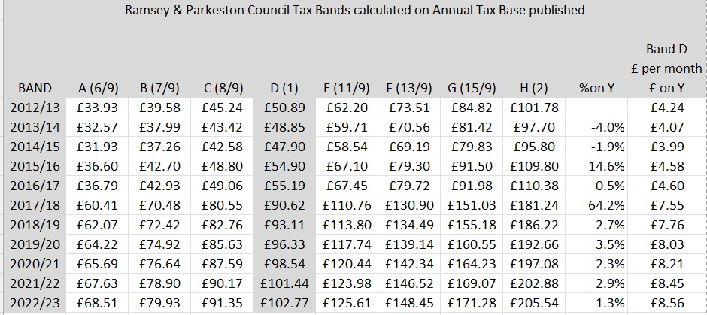

Below is an historical breakdown of the weekly costs on Tax Bands based on the Annual Tax Base of £102.77 for 2022/23.

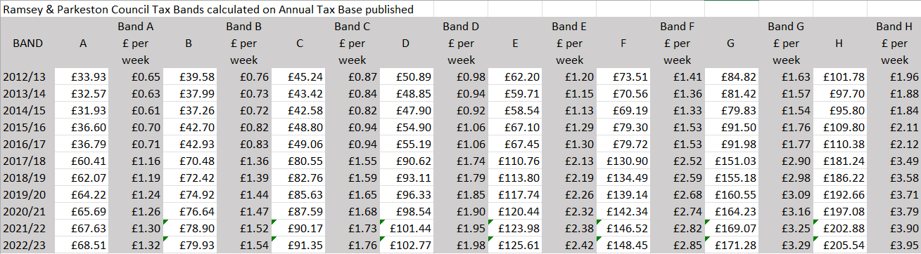

The upper limit of the RPPC bank balance is directed by the Audit Commission to be no more than 1.5 times the amount of the actual precept request: £74,168 x 1.5 = £111,252, therefore in submitting this precept request detailed monitoring of the bank balance is a future priority requirement.

Credit Debit

Balance brought forward 01 April 21 £103,585

Expenditure predicted to end March 22 £84,446

Income predicted to end March 22
Precept £72,418
Burials/memorials £1,000
Lodge Rent £7,392

Predicted Balance as at 1st April 2022 £99,949

I therefore recommend this budget to the Ramsey and Parkeston Parish Council to continue delivering best value to the parishioners of the Council.

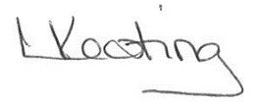
Lin Keating
Responsible Financial Officer
Dated: 2nd December 2021

This recommendation has been agreed by those present at the meeting of the Ramsey & Parkeston Parish Council held on 13th January 2022 with approval given for the precept request to be submitted as directed to Tendring District Council by 21st January 2022.

Proposed by:

Councillor…………………………. seconded by Councillor ……………………………

Signed by the Chairman……………………………………..

Name:…………………………………………………………

Dated:

Witnessed by Councillor………………………………….

Signature: …………………………………………,,……..

Name:………………………………………………………

Dated:

